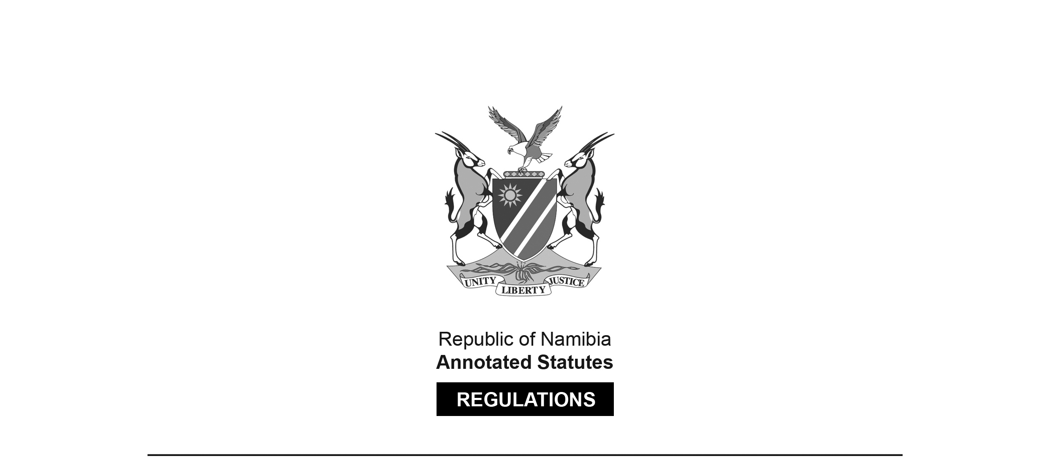

REGULATIONS SURVIVING IN TERMS OF

Health Professions Act 16 of 2024

section 95(10)

Regulations relating to the Scope of Practice   
of the Profession of Medical Technology

Government Notice 87 of 2012

([GG 4913](http://www.lac.org.na/laws/2012/4913.pdf))

came into force on date of publication: 30 March 2012

These regulations were made in terms of section 55 of the Allied Health Professions Act 7 of 2004, which was repealed by the Health Professions Act 16 of 2024. Pursuant to section 95(10) of the Health Professions Act 16 of 2024, they are deemed to have been made under that Act.

The Government Notice which publishes these regulations notes that they were made   
on the recommendation of the Allied Health Professions Council of Namibia.

ARRANGEMENT OF REGULATIONS

1. Definitions

2. Scope of practice of medical technologists

**Definitions**

**1.** In these regulations a word or expression to which a meaning has been assigned in the Act bears that meaning, and unless the context otherwise indicates -

“dentists” means a person registered as such under the Medical and Dental Act, 2004 (Act No. 10 of 2004);

[The word “dentists” (plural) should be “dentist” (singular). T**he Medical and Dental Act 10 of 2004 has been replaced by the Health Professions Act 16 of 2024.]**

“medical practitioner” means a person registered as such under the Medical and Dental Act, 2004 (Act No. 10 of 2004); and

[T**he Medical and Dental Act 10 of 2004   
has been replaced by the Health Professions Act 16 of 2024.]**

“the Act” means the Allied Health Professions Act, 2004 (Act No. 7 of 2004).

**[The Allied Health Professions Act 7 of 2004   
has been replaced by the Health Professions Act 16 of 2024.]**

**Scope of practice of medical technologists**

**2.** (1) Subject to provisions of subregulation (2), all the acts performed by a medical technologist during the analysis of human tissue, body fluid or excretion, if that analysis is performed to enable a dentist or medical practitioner to make a diagnosis, to institute or conduct dental, medical treatment or procedures based on the results of that analysis, must be regarded, for the purposes of the Act, to be acts pertaining to the scope of practice of a medical technologists.

(2) When carried out during a dissection or analysis referred to in subregulation (1), the following acts must for the purposes of the Act be considered not to be acts pertaining to the profession of medical technology -

(a) the labeling, centrifuging and transferring of specimens or the transcribing of results already manually or mechanically recorded;

(b) the preparation of equipment, culture media and reagents;

(c) in the case of qualitative and semi-quantitative tests, the adding of the test reagent to a sample or vice versa;

(d) in the case of microbiological tests, the establishing of primary inoculation of test material to be cultured on to appropriate media; and

(e) staining slide preparation for microscopic examination.

(3) The performance by a medical technologist of any act pertaining to the profession of a medical technologist is subject to the request for analysis by a registered medical practitioner or dentist and must pertain to the professional scope of a medical technologist as set in subregulation (1).

(4) Medical technologists are responsible for assuring appropriate, reliable and accurate laboratory test results, which contribute to the diagnosis, treatment, prognosis, and prevention of physiological and pathological conditions in humans.

(5) In order to comply with subregulation (4) a medical technologist has to comply with the following requirements -

(a) performing the correct test on the right person;

(b) producing accurate laboratory test results by analysing specimens and validating results using established scientific protocols;

(c) verifying relevant data and ensuring that appropriate specimens are procured according to established scientific protocols;

(d) correlating and interpreting laboratory test data;

(e) understanding the principles and measurement of uncertainty of different analytical techniques on specimens that originate from a variety of sources;

(f) disseminating laboratory test information to clinicians and patients in a timely manner;

(g) applying critical thinking skills to constructively solve problems;

(h) assessing, developing, evaluating and implementing new laboratory test methods based on sound scientific principles;

(i) developing, implementing, and reporting results of research carried out;

(j) practicing according to the principles of established quality management systems while ensuring efficient utilization of resources;

(k) designing, implementing and evaluating processes for the education of new laboratory personnel, and the continued education of existing medical laboratory professionals;

(l) conducting professional practice according to established protocols, safety guidelines, ethical guidelines and existing legislation; and

(m) restricting the practice to the category in which he or she is registered and in which he or she has received appropriate education and training in and is competent in.

(6) The following acts and omissions apply to medical technologists, intern medical technologists, medical laboratory technicians or student medical laboratory technicians -

(a) a medical technologist may only perform acts pertaining to the profession of medical technology for which he or she is adequately trained and competent in;

(b) a medical technologist may not consult with any person in regard to any work performed by him or her in his or her profession or provide information concerning a patient to any person other than the registered medical practitioner or dentist at whose instance such work was undertaken and without the express consent of the patient;

(c) a student or intern medical technologist may only perform professional acts under the supervision of a medical technologist registered in his or her field of study and those acts are limited to acts directly related to his or her training in the field of medical technology;

(d) a clinical pathology technician may only perform work in a chemical pathology, microbiology or haematology under the supervision of a registered medical technologist who is registered in the category in which the act is being performed;

(e) a haematology technician may only perform work in hematology under the supervision of a registered medical technologist who is registered in the category of hematology or clinical pathology;

[The spelling of “haematology” in paragraph (e) is inconsistent.]

(f) a histopathology technician may only perform work in histopathology under the supervision of a registered medical technologist who is registered in the category of histopathology;

(g) a chemical pathology technician may only perform work in chemical pathology under the supervision of a registered medical technologist who is registered in the category of chemical pathology or clinical pathology;

(h) a microbiology technician may only perform work in microbiology under the supervision of a registered medical technologist who is registered in the category of microbiology or clinical pathology;

(i) a blood transfusion technician may only perform work in blood transfusion under the supervision of a registered medical technologist who is registered in the category of blood transfusion; and

(j) a cytology technician may only perform work in cytology under the supervision of a registered medical technologist who is registered in the category of cytology.